Group Member Names: Blessing, Jai, Jon, Manuel

Course and Quarter: ENGR 114 - Winter 2019

Date: 3/16/19

Revision Number: 3

**Remote Fish Feeder**

#### **Problem Statement:**

For our team project, the group was tasked to set up a hydroponic garden / fish tank installation using a hardware such as sensors that could measure the temperature pH and water depth in the fish tank and help determine when the pump needs to be turned on. Using Python, the group has interacted an Arduino to dynamically collect sensor data and record the temperature over a set amount of time with the temperature displayed at regular intervals.

**Hardware Setup:**

**Bill of Materials:**

|  |  |  |  |  |
| --- | --- | --- | --- | --- |
| Part Name | Purpose | Item Name | URL | Price |
| Arduino | Microcontroller | SparkFun RedBoard | <https://www.sparkfun.com/products/13975> | $19.95 |
| Breadboard | Connect Circuit | Breadboard - Self-Adhesive (White) | <https://www.sparkfun.com/products/12002> | $4.95 |
| Base | Hold Boards | Arduino and Breadboard Holder | <https://www.sparkfun.com/products/11235> | $3.95 |
| USB Cable | Connect to Computer | SparkFun USB Mini-B Cable - 6 Foot | <https://www.sparkfun.com/products/11301> | $3.95 |
| Jumper Wires | Circuit Connections | Jumper Wires Standard 7" M/M - 30 AWG (30 Pack) | <https://www.sparkfun.com/products/11026> | $1.95 |
| Stepper Motor | Drive Feeder | Stepper Motor with Cable | <https://www.sparkfun.com/products/9238> | $14.95 |
| Motor Driver | Control Motor | EasyDriver - Stepper Motor Driver | <https://www.sparkfun.com/products/12779> | $14.95 |
| Photocell | Light Sensor | Mini Photocell | <https://www.sparkfun.com/products/9088> | $1.50 |
| Green LED | Ready Indicator | LED - Basic Green 5mm | <https://www.sparkfun.com/products/9592> | $0.35 |
| Yellow LED | Run Indicator | LED - Basic Yellow 5mm | <https://www.sparkfun.com/products/9594> | $0.35 |
| Red LED | Error Indicator | LED - Basic Red 5mm | <https://www.sparkfun.com/products/9590> | $0.35 |
| 3 x 330 Ω  Resistor | Limit Current | Resistor 330 Ω 1/6th Watt PTH | <https://www.sparkfun.com/products/8377> | $0.75 |
| 1 x 10k Ω  Resistor | Divide Voltage | Resistor 10k Ω 1/6th Watt PTH | <https://www.sparkfun.com/products/8374> | $0.25 |

**Hardware Schematic:**

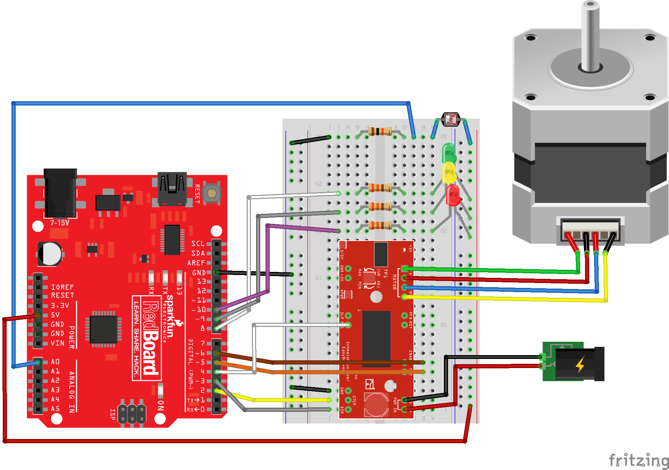

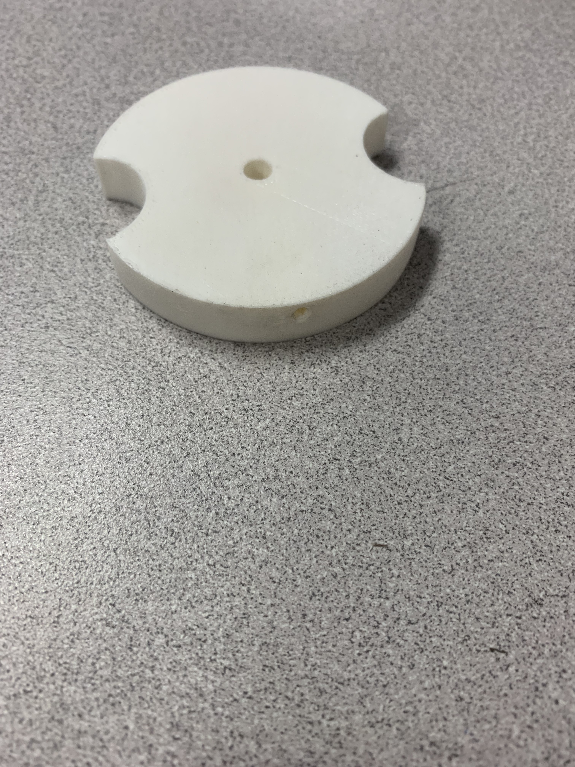

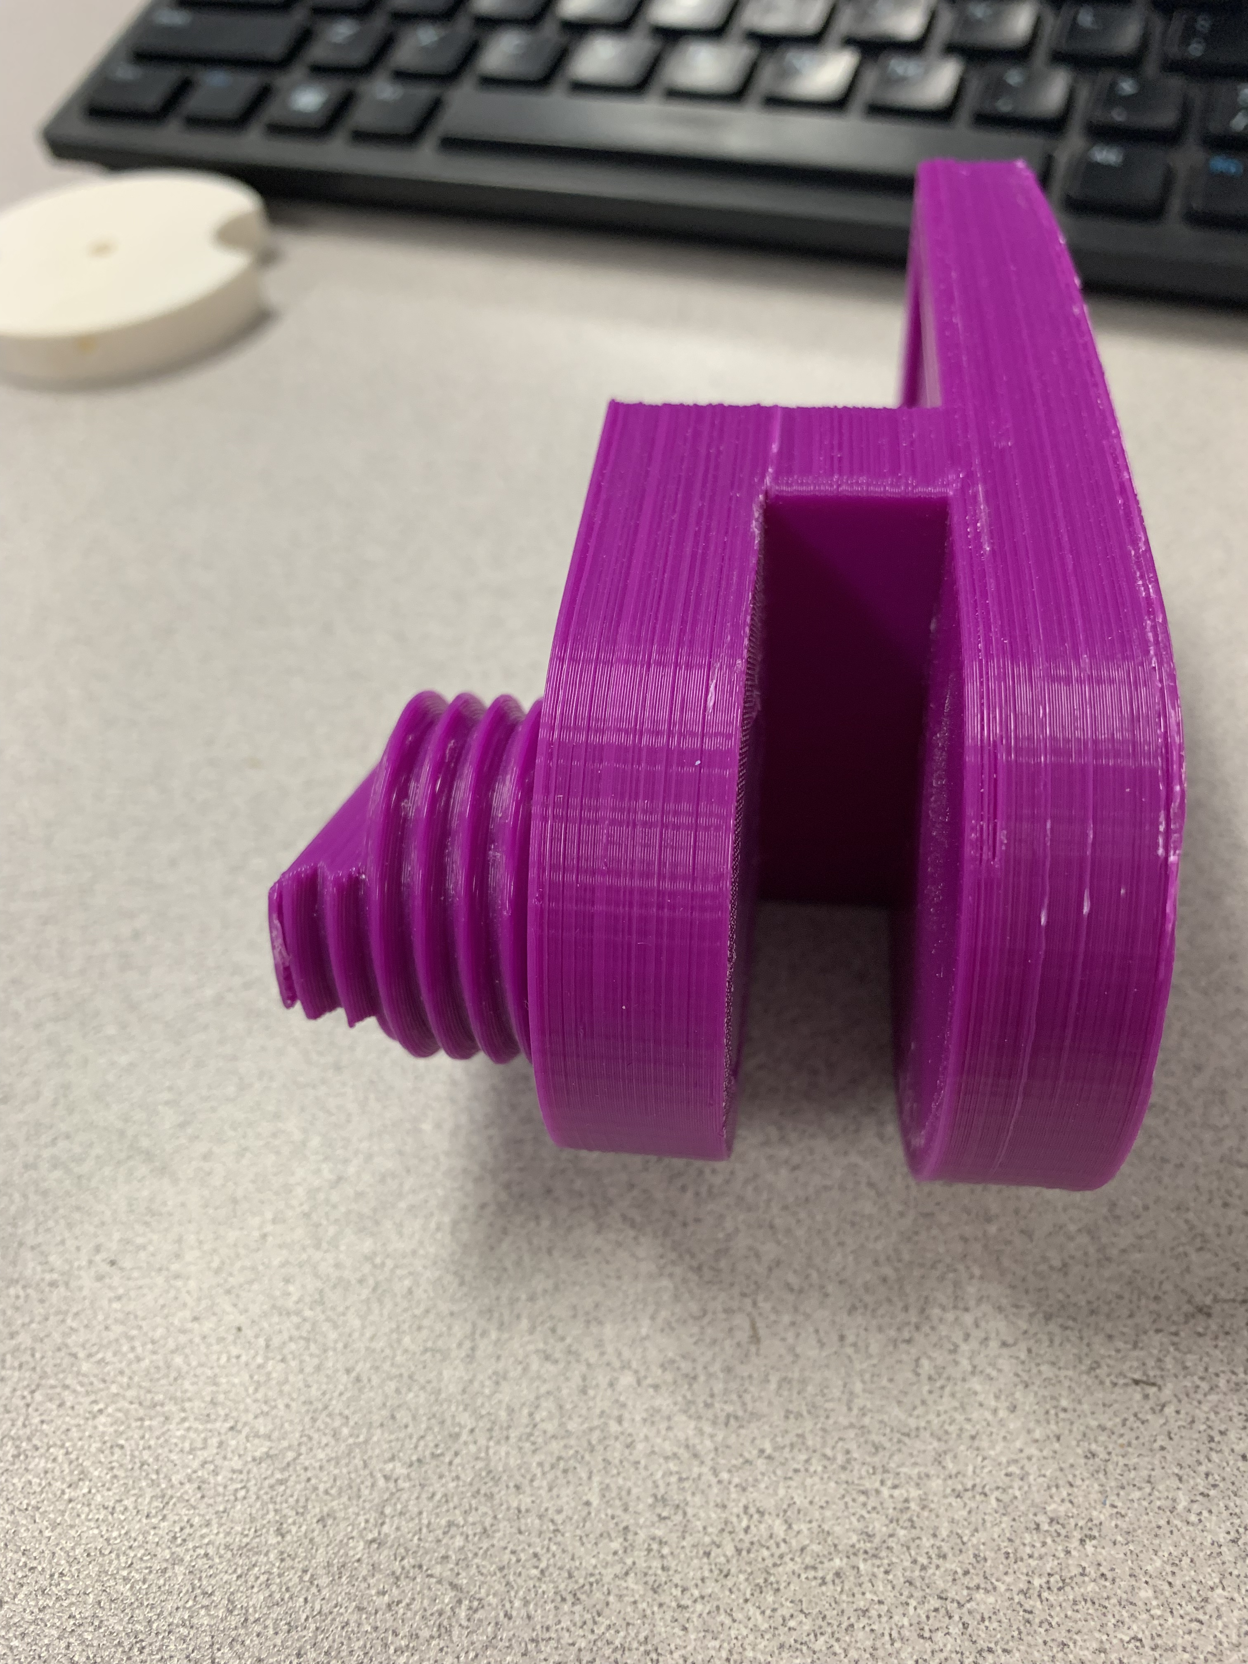

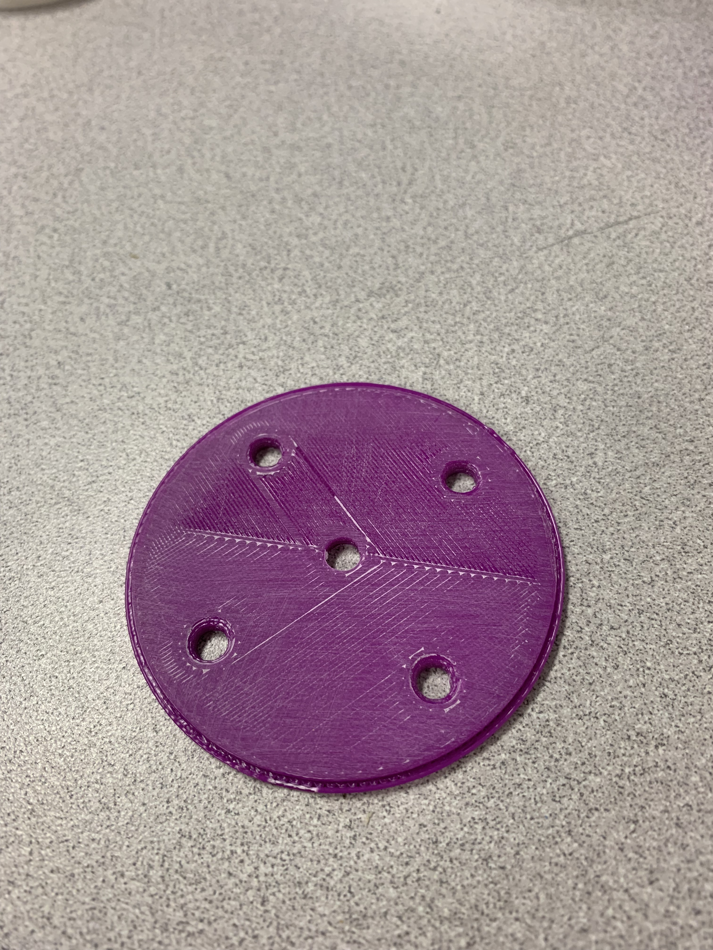

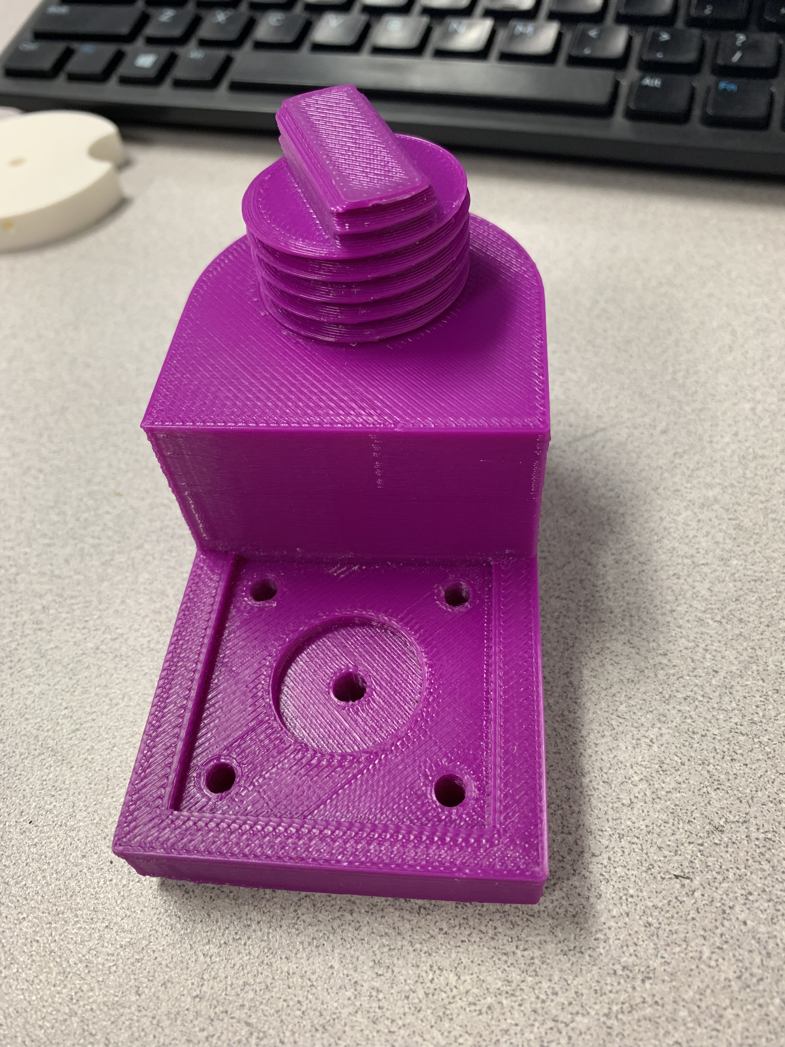

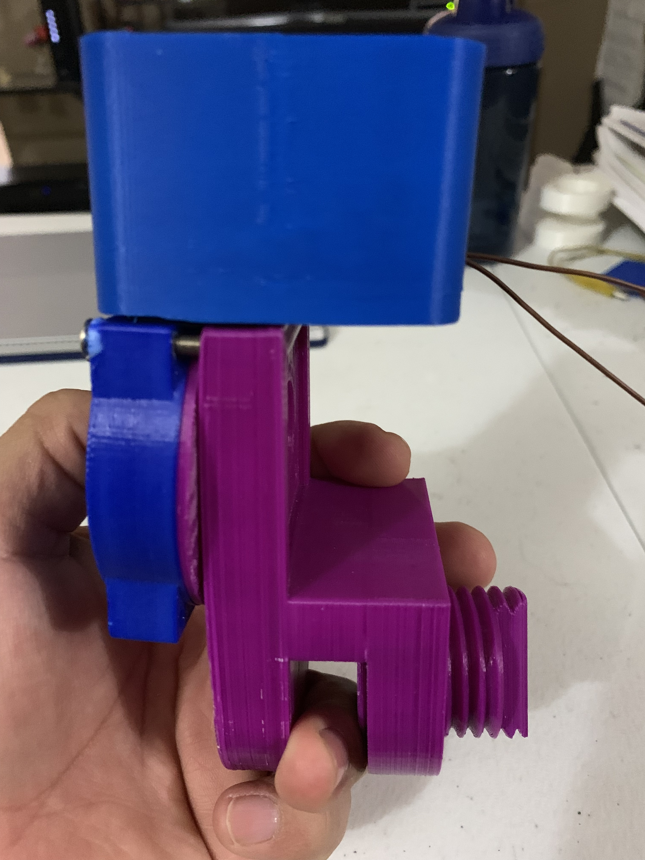

**Hookup Guide:**

|  |  |  |  |  |
| --- | --- | --- | --- | --- |
| Part | Pin | Connector | Pin | Part |
| Arduino | 2 | Jumper | DIR | Motor Driver |
| Arduino | 3 | Jumper | STEP | Motor Driver |
| Arduino | 4 | Jumper | MS1 | Motor Driver |
| Arduino | 5 | Jumper | MS2 | Motor Driver |
| Arduino | 6 | Jumper | ENABLE | Motor Driver |
| Arduino | 8 | Jumper w/ 330 Ω | Cathode : Anode to 5V | Green LED |
| Arduino | 9 | Jumper w/ 330 Ω | Cathode : Anode to 5V | Yellow LED |
| Arduino | 10 | Jumper w/ 330 Ω | Cathode : Anode to 5V | Red LED |
| Arduino | A0 | Jumper w/ 10k Ω to GND | Non-Polar : Other to 5V | Photocell |
| Arduino | 5V | Jumper | 5V | Breadboard |
| Arduino | GND | Jumper | GND | Breadboard |
| Stepper Motor | A (Red) | Motor Lead | Coil A+ | Motor Driver |
| Stepper Motor | C (Green) | Motor Lead | Coil A- | Motor Driver |
| Stepper Motor | B (Yellow) | Motor Lead | Coil B+ | Motor Driver |
| Stepper Motor | D (Blue) | Motor Lead | Coil B- | Motor Driver |
| AC Adapter | + (Red) | Jumper | M+ | Motor Driver |
| AC Adapter | - (Black) | Jumper | GND | Motor Driver |

### Connected Hardware

Arduino is connected to the computer via a mini-USB.

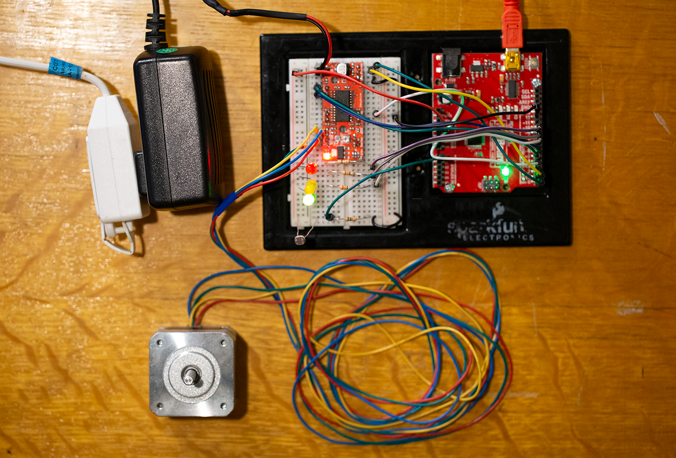**Images:**

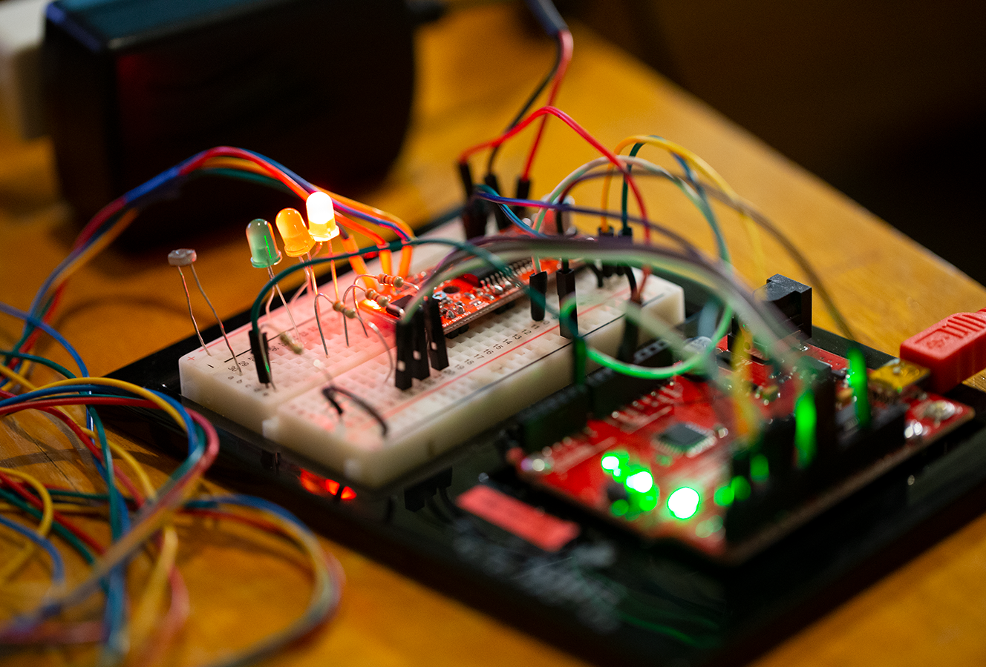

#### Macintosh HD:Users:Jon:Desktop:ENGR:ENGR 114:Project:Photos:Circuit Photo 2 Small.png

#### Code:

**Python Code (from a .py-file)**

import time

import serial

import urllib

import pandas as pd

import numpy as np

#function to read and return value of single thingspeak field

def read_field_thingspeak(channel, api_key, field, results):

read_link = 'https://api.thingspeak.com/channels/' + str(channel) + '/fields/' + str(field) + '.csv?api_key=' + str(api_key) +'&results=' + str(results)

df = pd.read_csv(urllib.request.urlopen(read_link))

df.drop(['created_at'], axis=1, inplace=True)

return np.array(df)[0][1]

#function that reads thingspeak status

def read_status_thingspeak(channel, api_key, results):

read_link = 'https://api.thingspeak.com/channels/' + str(channel) + '/status.csv?api_key=' + str(api_key) +'&results=' + str(results)

return urllib.request.urlopen(read_link)

#function that formats and requests a link to write to two thingspeak fields at once

def write_to_thingspeak(api_key, field1, value1, field2, value2):

write_link = 'https://api.thingspeak.com/update?api_key=' + str(api_key) + '&field'+ str(field1) +'=' + str(value1) +'&field'+ str(field2) +'=' + str(value2)

urllib.request.urlopen(write_link)

#function to write status to thingspeak in addtion to both fields

def write_to_thingspeak_status(api_key, field1, value1, field2, value2, status):

write_link = 'https://api.thingspeak.com/update?api_key=' + str(api_key) + '&field'+ str(field1) +'=' + str(value1) +'&field'+ str(field2) +'=' + str(value2) +'&status=' + status

urllib.request.urlopen(write_link)

#declare variables related for specific thingspeak channel

channel = '720608'

read_api_key = 'RRGPJE5YQ8JJPRIR'

write_api_key='C7MKD36DWMJS69UL'

#declare variable for COM port for serial communication

com = '/dev/cu.usbserial-DN051CFK'

#declare variables to validate user input

function_selection = ''

action = ''

print('Fish Feeder Transceiver')

while(function_selection != '0'):

print('***Main Menu***')

#prompt user to choose between transmitter or receiver functionality

function_selection = input('Choose the following:\n1: Transmitter\n2: Receiver\n0: Exit\n')

if function_selection == '1':

#while loop that runs for duration of program to prompt for user input

while(action != '0'):

#initialization delay to prevent multiple thingspeak write attempts within a short period.

print('\nInitializing', end='')

for i in range(15):

print('.', end='')

time.sleep(1)

#prompt user for input and move through program accordingly

action = input('\n\n***Transmitter***\nChoose the following:\n1: Feed Fish!\n2: Last Time Fish Fed?\n3: Feeder Status\n0: Exit\n')

if action == '1':

#read initial feeder status

status = read_field_thingspeak(channel,read_api_key,1,1)

if(status != 0):

#if status not empty write the run command to thingspeak

write_to_thingspeak(write_api_key,1,1,2,1)

#communication delay to ensure time for arduino to process command and respond to thingspeak

print('Communicating', end='')

for i in range(20):

print('.', end='')

time.sleep(1)

#read feeder status to check if feeding was succesful

status = read_field_thingspeak(channel,read_api_key,1,1)

if(status==0):

print('\nFeeder Empty!')

continue

elif(status == 1):

#read feeder command, if command is still 1 then hardware never read command, if 0 then hardware ran command

command = read_field_thingspeak(channel,read_api_key,2,1)

if(command == 1):

print('\nFeeder Not Responding!')

else:

print('\nFood Dispensed.')

else:

#if status is 0 then the feeder is empty

print('\nFeeder Empty!')

elif action == '2':

#query time last fed and report to user

df = pd.read_csv(read_status_thingspeak(channel, read_api_key, 1))

print('Fish last fed', np.array(df)[0][0])

continue

elif action == '3':

#query feeder status and report to user

#field 1:status(0=EMPTY, 1=READY)

#field 2:command(0=IDLE, 1=RUN)

status = read_field_thingspeak(channel,read_api_key,1,1)

command = read_field_thingspeak(channel,read_api_key,2,1)

if(status==0):

print('Feeder Empty!')

elif(status==1):

print('Feeder Ready.')

elif action == '0':

#terminate program

print("Transmitter Terminated.")

break

else:

print('Invalid Input!\n\n')

continue

elif function_selection == '2':

print('***Receiver***')

try:

#initialize serial communication

ser = serial.Serial(com, 9600, timeout=1)

time.sleep(2)

except:

print('Serial Communication Error!\nReturning to Main Menu.\n\n')

else:

#while loop that runs while serial communication is open

while ser.is_open:

#query thingspeak for feeder status and command

#field 1:status(0=EMPTY, 1=READY)

#field 2:command(0=IDLE, 1=RUN)

status = read_field_thingspeak(channel,read_api_key,1,1)

command = read_field_thingspeak(channel,read_api_key,2,1)

#reset input buffer to ensure latest serial output from board is read

ser.reset_input_buffer()

board_status = ser.readline()

#board is communicating empty status

if(board_status == b'EMPTY\r\n'):

if(status!=0):

write_to_thingspeak(write_api_key,1,0,2,0)

time.sleep(15)

#board is commmunicating ready status

if(board_status == b'READY\r\n'):

#command is IDLE

if(command == 0):

if(status != 1):

write_to_thingspeak(write_api_key,1,1,2,0)

time.sleep(15)

#command is RUN

if(command == 1):

ser.write(b'1')

time.sleep(15)

write_to_thingspeak_status(write_api_key,1,1,2,0,'Food Dispensed')

#delay

time.sleep(1)

#close serial communication and terminate program

ser.close()

print('Serial Communication Closed. Receiver Terminated.')

elif(function_selection =='0'):

print('Program Terminated.')

break

else:

print('Invalid Input!\n\n')

continue

**Arduino Code or MicroPython code (from a .ino-file or .py-file)**

* Fish_Feeder.ino

* Team Fish Food Group Project

* ENGR 114 - Winter 2019

* Arduino Code by Jon Golobay

* Last Edited: 3/11/19

*/

//Declare I/O

#define stp 2

#define dir 3

#define MS1 4

#define MS2 5

#define EN 6

#define green 8

#define yellow 9

#define red 10

//declare and initialize variables

int user_input = 0;

int photoresistor = 0;

int threshold = 150; //photoresistor threshold, determined experimentally and may depend on lighting conditions

void setup() {

//intialize hardware setup with intial states

Serial.begin(9600);

pinMode(green, OUTPUT);

pinMode(yellow, OUTPUT);

pinMode(red, OUTPUT);

pinMode(stp, OUTPUT);

pinMode(dir, OUTPUT);

pinMode(MS1, OUTPUT);

pinMode(MS2, OUTPUT);

pinMode(EN, OUTPUT);

//LEDs are active LOW, write to HIGH to initialize to off

digitalWrite(red, HIGH);

digitalWrite(green, HIGH);

digitalWrite(yellow, HIGH);

//initialize step motor

resetMotor();

}

void loop() {

//delay to slow down serial output

delay(500);

//read analog value of voltage change due to photresistor

photoresistor = analogRead(A0);

if(photoresistor>threshold) {

//LED Switch: Red ON and Green/Yellow OFF

digitalWrite(red, LOW);

digitalWrite(green, HIGH);

digitalWrite(yellow, HIGH);

//output status to serial

Serial.println("EMPTY");

//always read serial input to ensure feed requests while feeder is empty are read and disregarded

//failure to do so will store requests until feeder is ready and run as many times as requested

while(Serial.available()) {

user_input = Serial.read();

}

}

if(photoresistor<threshold) {

//LED Switch: Green ON and Red/Yellow OFF

digitalWrite(green, LOW);

digitalWrite(yellow, HIGH);

digitalWrite(red, HIGH);

//output status to serial

Serial.println("READY");

//reads serial input looking for dispense trigger which is byte='1'

while(Serial.available()) {

user_input = Serial.read();

if (user_input =='1') {

//LED Switch: Yellow ON and Green OFF

digitalWrite(green, HIGH);

digitalWrite(yellow, LOW);

//Step Motor Enable

digitalWrite(EN, LOW);

//output status to serial

Serial.println("DISPENSING");

//loop to run step motor for 800 steps(step number determined experimentally and dependent on dispense mechanism)

for(int x= 1; x<800; x++) {

digitalWrite(stp,HIGH); //Trigger one step

delay(1);

digitalWrite(stp,LOW); //Pull step pin low so it can be triggered again

delay(1);

}

//output status to serial

Serial.println("COMPLETE");

//LED Switch: Yellow ON and Green OFF

digitalWrite(yellow, HIGH);

digitalWrite(green, LOW);

//Step Motor Disable

digitalWrite(EN, HIGH);

}

}

}

}

//function to initialze step motor to a default state

void resetMotor() {

digitalWrite(stp, LOW);

digitalWrite(dir, LOW); //direction pin LOW to go "forward"

digitalWrite(MS1, HIGH);

digitalWrite(MS2, HIGH);

digitalWrite(EN, HIGH); //enable pin HIGH for disable

}

#### Future Work:

This project was quite interesting to set up the hydroponic fish garden. While using Python, the program was taking time initialize the code itself to get some values of the temperature vs time. For future work, another group could write a program that can control not only the temperature but other aspects such as the lighting, water flow/waste inside the fish garden. And all of these could be fully automated and controlled remotely using a smartphone.

#### Results:

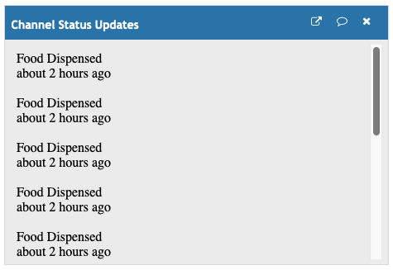

#### License

# The MIT License Copyright <2019> <Team Fish Food>